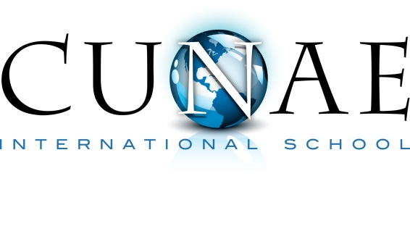
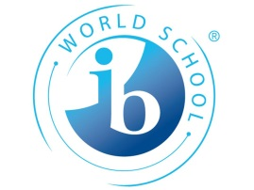
Programme of Inquiry
Cycle 2 2014/2016 • Grades 1-2

Who We Are | Where we are in place and time | How we express ourselves | How the world works | How we organize ourselves | Sharing the Planet
An inquiry into the nature of the self; beliefs and values; personal, mental, social and spiritual health; human relationships including families, friends, communities and cultures; rights and responsibilities; what it means to be human | An inquiry into orientation in place and time; personal histories; homes and journeys; the discoveries, explorations and migrations of human kind; the relationships between the interconnectedness of individuals and civilizations, from local and global perspectives. | An inquiry into the ways in which we discover and express ideas, feelings, nature, culture, beliefs and values; the ways in which we reflect on, extend and enjoy our creativity; our appreciation of the aesthetic. | An inquiry into the natural world and its laws; the interaction between the natural world (physical and biological) and human societies; how humans use their understanding of scientific principles; the impact of scientific and technological advances on society and on the environment. | An inquiry into the interconnectedness of human-made systems and communities; the structure and function of organizations; social decision-making; economic activities and their impact on humankind and the environment | An inquiry into rights and responsibilities in the struggle to share finite resources with other people and with other living things; communities and the relationships within and between them; access to equal opportunities; peace and conflict resolution
Central Idea:  Home  Personalizing our homes is a reflection of who we are | Central Idea:  Public Places  Public places strengthen communities and provide people opportunities to connect. | Central Idea:  Scaredy Cats  Fear is an emotion felt by all ages and cultures. Expressing & communicating fears encourages self growth while helping others | Central Idea:  Movement & motion  People apply basic scientific principles in a variety of ways to solve problems and meet needs | Central Idea:  From Field to Table  The food we eat goes through several stages from their origin to their consumption. | Central Idea:  What’s in the Bin? Reduce, Reuse, Recycle  Our personal choices can change our environment. Waste products are made of different materials that can be recycled, re-used or conserved. It is our responsibility to act on this knowledge appropriately
Subject Focus  PSPE | Subject Focus  Social Studies | Subject Focus  Social Studies | Subject Focus  Science and Technology | Subject Focus  Science; Social Studies | Subject Focus  PSPE, Science
Key Concepts  Form, Function, Change, Responsibility, Connection | Key Concepts  Function, Causation Connection | Key Concepts  Perspective, Connection, Reflection | Key Concepts  Form, Function, Causation | Key Concepts  Form, Change, Connection | Key Concepts  Causation, Responsibility, Change
Related Concepts  Structure, Role, Growth, Relationships, Values | Related Concepts  Structure, Consequences, Relationships, Systems | Related Concepts  Beliefs, tradition, culture | Related Concepts  Properties, Systems, Consequences, Impact | Related Concepts  Properties, Growth, Cycles, Interdependence | Related Concepts  Sequences, patterns, citizenship
Lines of Inquiry  - The nature of home  - Why we need a home  - How we make home personal  - How a home can create a sense of belonging  - How our culture affects our home  - How our beliefs and traditions affects our home | Lines of Inquiry  - Different public places and their attributes  - How and by whom these places are used (the needs they meet)  - How public places affect the environment in their development  - The systems that public places have to make them work e.g. opening hours, regulations etc. | Lines of Inquiry  - Real and make believe fears  - Cultural similarities and differences of fears and feelings  - Strategies to deal with fears | Lines of Inquiry  - The effect of applying various pushes/pulls on different objects  - How/why magnets make things move without touching them  - What objects are magnetic  - How gravity works  - How force affects motion | Lines of Inquiry  - The changes foods undergo before they are sold in shops. (change)  - The roles people play putting food on our table. (change/connection)  - Where do the food we eat come from. (form) | Lines of Inquiry  - Resources that we waste  - How waste effects the environment  - How do we minimize our impact on the environment – reduce, reuse, recycle
Transdisciplinary Skills  Research, Thinking, Communication | Transdisciplinary Skills  Social, Thinking, communication | Transdisciplinary Skills  Thinking (questioning/logic) | Transdisciplinary Skills  Thinking, Self-management, Research | Transdisciplinary Skills  Research, thinking | Transdisciplinary Skills  Thinking, research
Learner Profile  Communication, Caring, Thinker, Risk-taker | Learner Profile  Knowledgeable, Inquirers, Caring, Communicators (Open minded in the future) | Learner Profile  Courageous, Thinker | Learner Profile  Thinker, Reflective | Learner Profile  Knowledgeable, Balanced, Inquirers | Learner Profile  Caring, Reflective, thinkers, communicators, inquirers
Attitudes  Tolerance, Respect, Creativity | Attitudes  Appreciation, Tolerance,  Integrity | Attitudes  Independence, Confidence | Attitudes  Commitment, Creativity, Curiosity | Attitudes  Independence, Curiosity,  Enthusiasm | Attitudes  Respect, Commitment

