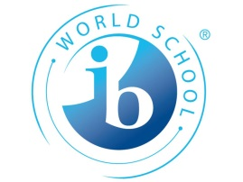
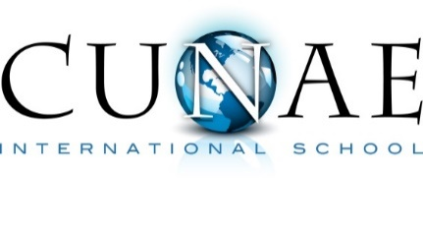
Programme of Inquiry
2016-2017 • PreK-Kindergarten
Who We Are | Where we are in place and time | How we express ourselves | How the world works | How we organize ourselves | Sharing the Planet
An inquiry into the nature of the self; beliefs and values; personal, mental, social and spiritual health; human relationships including families, friends, communities and cultures; rights and responsibilities; what it means to be human | An inquiry into orientation in place and time; personal histories; homes and journeys; the discoveries, explorations and migrations of human kind; the relationships between the interconnectedness of individuals and civilizations, from local and global perspectives. | An inquiry into the ways in which we discover and express ideas, feelings, nature, culture, beliefs and values; the ways in which we reflect on, extend and enjoy our creativity; our appreciation of the aesthetic. | An inquiry into the natural world and its laws; the interaction between the natural world (physical and biological) and human societies; how humans use their understanding of scientific principles; the impact of scientific and technological advances on society and on the environment. | An inquiry into the interconnectedness of human-made systems and communities; the structure and function of organizations; social decision-making; economic activities and their impact on humankind and the environment | An inquiry into rights and responsibilities in the struggle to share finite resources with other people and with other living things; communities and the relationships within and between them; access to equal opportunities; peace and conflict resolution
Central Idea:  Me and My Body  How the different parts of my body work for me. | Central Idea:  Exploring Space  Human beings find ways to travel beyond home and discover new worlds. | Central Idea:  Let’s Celebrate  How our creativity helps us celebrate in different ways | Central Idea:  Shadows & Reflections  Light creates shadows and reflections. | Central Idea:  Being a Helper  Community Helpers are people that make your community a better place; everybody can be a helper in some way. | Central Idea:  Food from Earth  People use the Earth’s resources to produce and provide food.
Lines of Inquiry  - Identifying parts of body, including systems and organs  - Learning healthy habits  - Measuring and comparing body size  - Similarities and differences of my body to the children around the world | Lines of Inquiry  - Surviving in space  - Mapping space  - The characteristics of planets that support life  - Vehicles for getting to space  - Machines for finding out about space | Lines of Inquiry  - Reasons to celebrate  - Rituals for celebration  - Resources and products used for celebration  - Comparing celebration across cultures | Lines of Inquiry  - Identifying what materials and surfaces can reflect  - Places you can see your shadow  - Discovering objects that make shadows  - Discovering what makes a reflection  - What makes a shadow | Lines of Inquiry  - Defining helping and its purpose.  - Researching different helping opportunities.  - Where and when we can be helpful.  - Developing a helping plan. | Lines of Inquiry  - People eat a variety of foods that come from the Earth.  - There are many types of farms to raise food.  - There are beneficial and harmful insects.  - Seeds require sun, water and soil to grow.
Key Concepts  Form, function, Responsibility, Causation, Change | Key Concepts  Connection, Change | Key Concepts  Perspective, Connection, Responsibility | Key Concepts  Causation, Form, Reflection, Function | Key Concepts  Responsibility, Connection, Reflection | Key Concepts  Form, Function, Change
Related Concepts  Similarities/Differences, Growth, Systems, Initiatives, Consequences | Related Concepts  Systems, Homeostasis, Growth, Adaptation | Related Concepts  Beliefs, Systems, Relationships, Values, Initiative | Related Concepts  Properties, pattern, consequences, impact, evidence, | Related Concepts  Relationships, Interdependence, Citizenship, Values, Behavior | Related Concepts  Properties, System, Cycle
Transdisciplinary Skills  Research, Communication, Self-management | Transdisciplinary Skills  Thinking, Research | Transdisciplinary Skills  Thinking (acquisition, analysis), Social (respecting others), Communication | Transdisciplinary Skills  Thinking, Self management, Research | Transdisciplinary Skills  Social skills, Communication, Self-management | Transdisciplinary Skills  Self-management, Research,
Learner Profile  Balanced, Inquirer | Learner Profile  Thinker, Knowledgeable | Learner Profile  Communication, Open-minded | Learner Profile  Knowledgeable, Thinker | Learner Profile  Caring, Principled | Learner Profile  Caring, Inquirer
Attitudes  Appreciation, Independence | Attitudes  Courageous, enthusiasm, Curiosity | Attitudes  Appreciation, Tolerance | Attitudes  Curiosity, Confidence | Attitudes  Integrity, Respect | Attitudes  Appreciation

